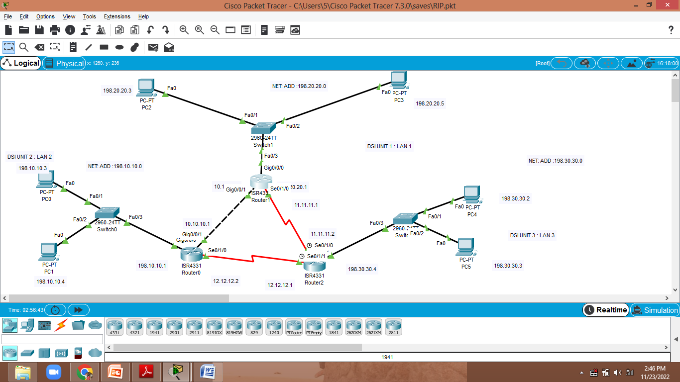

RIP :

Router 0:

10.0.0.0

12.0.0.0

198.10.10.0

Router 1:

10.0.0.0

11.0.0.0

198.20.20.0

Router 2:

11.0.0.0

12.0.0.0

198.30.30.0

Ospf :

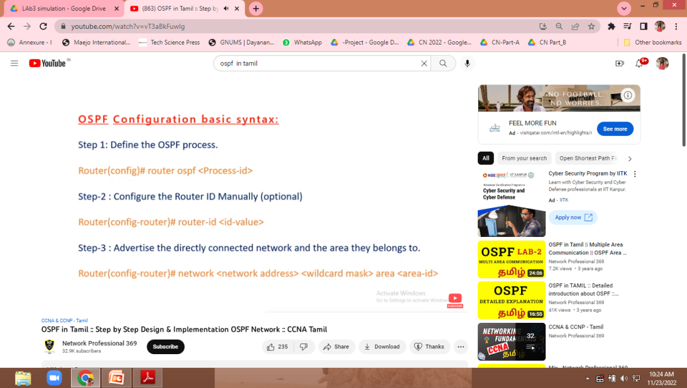

Router 0:

Router(config)#route ospf 1

Router(config-router)#router-id 198.10.10.0

Router(config-router)#network 198.10.10.0 0.0.0.255 area 0

Router(config-router)#network 10.0.0.0 0.255.255.255 area 0

Router(config-router)#network 12.0.0.0 0.255.255.255 area 0

Router 1:

Router(config)#route ospf 1

Router(config-router)#router-id 198.20.20.0

Router(config-router)#network 198.20.20.0 0.0.0.255 area 0

Router(config-router)#network 11.0.0.0 0.255.255.255 area 0

Router(config-router)#network 12.0.0.0 0.255.255.255 area 0

Router 2:

Router(config)#route ospf 1

Router(config-router)#router-id 198.30.30.0

Router(config-router)#network 198.30.30.0 0.0.0.255 area 0

Router(config-router)#network 11.0.0.0 0.255.255.255 area 0

Router(config-router)#network 12.0.0.0 0.255.255.255 area 0

Eigrp :

Router 0:

Router#en

Router#config t

Enter configuration commands, one per line. End with CNTL/Z.

Router(config)#router eigrp 100

Router(config-router)#network 198.10.10.0

Router(config-router)#network 10.0.0.0

Router(config-router)#network 12.0.0.0

Router(config-router)#no auto-summary

Router(config-router)#exit

Router#show ip route

**Router# show ip eigrp neighbor**

**Router#show ip eigrp topology**

**Router#show ip route eigrp**

**Router 1:**

Router#en

Router#config t

Enter configuration commands, one per line. End with CNTL/Z.

Router(config)#router eigrp 100

Router(config-router)#network 198.20.20.0

Router(config-router)#network 10.0.0.0

Router(config-router)#network 11.0.0.0

Router(config-router)#no auto-summary

Router(config-router)#exit

Router#show ip route

**Router# show ip eigrp neighbor**

**Router#show ip eigrp topology**

**Router#show ip route eigrp**

**Router 2:**

Router#en

Router#config t

Enter configuration commands, one per line. End with CNTL/Z.

Router(config)#router eigrp 100

Router(config-router)#network 198.30.30.0

Router(config-router)#network 11.0.0.0

Router(config-router)#network 12.0.0.0

Router(config-router)#no auto-summary

Router(config-router)#exit

Router#show ip route

**Router# show ip eigrp neighbor**

**Router#show ip eigrp topology**

**Router#show ip route eigrp**